Script-Controlled ACL – Restrict Record Access Based on Field Value
1. INTRODUCTION

1.1 Project Overview

Script-Controlled ACL – Restrict Record Access Based on Field Value is a ServiceNow-based access control project. The project uses a script-controlled Access Control List (ACL) to control who can view records based on a specific field value.

In this project, only users belonging to the EEE branch are allowed to view the specified record. Users from other branches are denied access. This provides controlled and secure access to records based on user information.

The ACL condition is tested using functional testing to verify that authorized users can access the record and unauthorized users are denied access.

2. Ideation Phase
2.1Empathize & Discover

Empathy Map Canvas:
An empathy map is a simple, easy to digest visual that captures knowledge about a user's behaviours and attitudes.
It is a useful tool to helps teams better understand their users. Creating an effective solution requires understanding the true problem and the person who is experiencing it. The exercise of creating the map helps participants consider things from the user's perspective along with his or her goals and challenges.

Example:
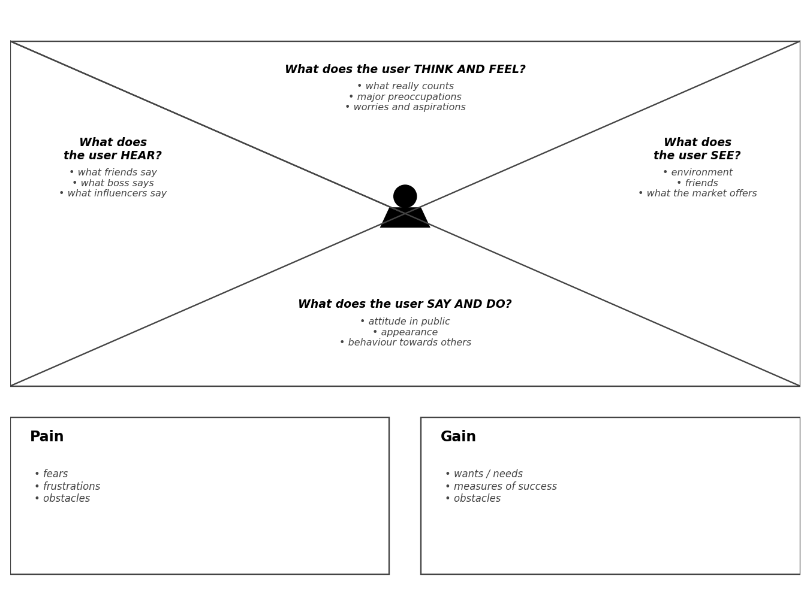
Example: Script-Controlled ACL – Restrict Record Access Based on Field Value

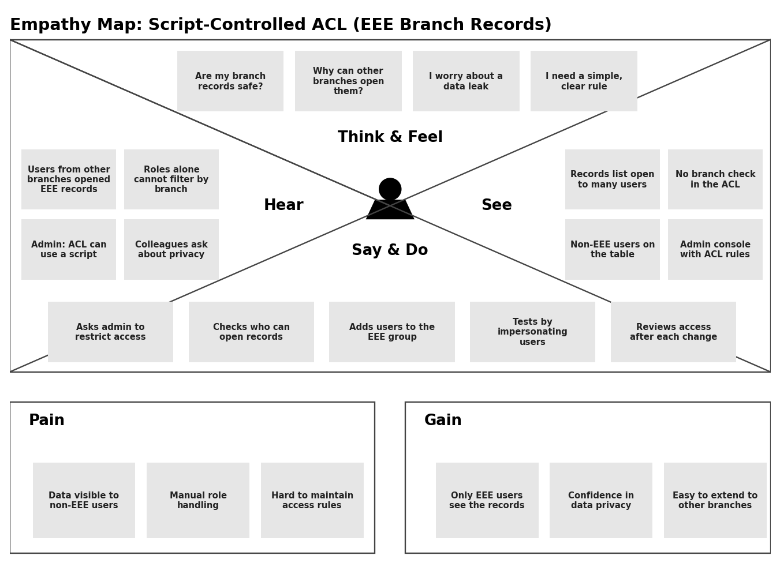
2.2 Define the Problem Statements
Customer Problem Statement Template:
Create a problem statement to understand your customer's point of view. The Customer Problem Statement template helps you focus on what matters to create experiences people will love.
A well articulated customer problem statement allows you and your team to find the ideal solution for the challenges your customers face. Throughout the process, you'll also be able to empathize with your customers, which helps you better understand how they perceive your product or service.

I am | Describe the customer and their attributes here
I'm trying to | List the thing they are trying to achieve here
But | Describe the problems or barriers that get in the way here
Because | Describe the reason the problems or barriers exist
Which makes me feel | Describe the emotions the result from experiencing the problems or barriers

Example:

I am | I'm trying to | But | Because | Which makes me feel
An EEE branch faculty who owns the EEE records | Make sure only EEE branch users can view the EEE records | Users from other branches can also open the records | The ACL uses only roles and cannot check the user's branch | Worried and insecure

Problem Statement (PS) | I am (Customer) | I'm trying to | But | Because | Which makes me feel
PS-1 | An EEE branch faculty who owns the EEE records | Make sure only EEE branch users can view the EEE records | Users from other branches can also open the records | The ACL uses only roles and cannot check the user's branch | Worried and insecure about data privacy
PS-2 | A ServiceNow admin who manages record access | Restrict access without creating separate tables or many roles for each branch | Manual role and group handling is slow and error-prone | There is no single reusable rule that decides access at runtime | Frustrated and overloaded

2.3 Brainstorm & Idea Prioritization Template

Brainstorm & Idea Prioritization Template:
Brainstorming provides a free and open environment that encourages everyone within a team to participate in the creative thinking process that leads to problem solving. Prioritizing volume over value, out-of-the-box ideas are welcome and built upon, and all participants are encouraged to collaborate, helping each other develop a rich amount of creative solutions.
Use this template in your own brainstorming sessions so your team can unleash their imagination and start shaping concepts even if you're not sitting in the same room.

Step-1: Team Gathering, Collaboration and Select the Problem Statement
Team gathering | Team members meet online or in person and agree on the roles: facilitator, note taker and ideators.
Set the goal | Find the best way to restrict record access so that only EEE branch users can view the records.
Problem statement | How might we restrict record access in ServiceNow so that only users of the EEE branch can view the EEE records?
Time to prepare | 10 minutes to prepare, 1 hour to collaborate, 2-8 people recommended.

Key rules of brainstorming
Stay in topic | Encourage wild ideas
Defer judgment | Listen to others
Go for volume | If possible, be visual
Step-2: Brainstorm, Idea Listing and Grouping
Brainstorm: each team member writes down as many ideas as possible for the problem statement.

Person 1 | Use role-based ACL only | Script-controlled ACL that checks the user's branch | Create a separate table for each branch
Person 2 | Hide records with a UI policy | Before-query business rule to filter records
Person 3 | Domain separation for each branch | Group-based ACL condition for EEE
Person 4 | Reusable Script Include for the branch check | Log and notify on denied access

Group ideas: similar ideas are grouped under a theme.

Access control rules | Data separation | Filtering and UI | Support and reuse
Role-based ACL only | Separate table per branch | UI policy to hide records | Reusable Script Include
Script-controlled ACL on branch | Domain separation | Before-query business rule | Log and notify on denied access
Group-based ACL condition

Step-3: Idea Prioritization

Ideas are placed on a grid by how important they are and how feasible they are. Ideas in the top-right area are taken forward.
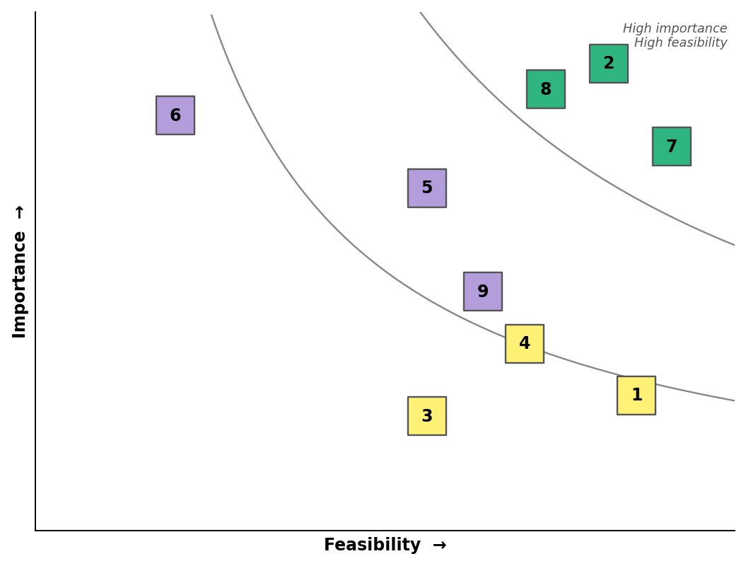
No. | Idea | Feasibility | Importance
1 | Role-based ACL only | High | Low
2 | Script-controlled ACL that checks the user's branch | High | High
3 | Separate table for each branch | Medium | Low
4 | UI policy to hide records | High | Low
5 | Before-query business rule | Medium | Medium
6 | Domain separation | Low | High
7 | Group-based ACL condition | High | High
8 | Reusable Script Include for the branch check | High | High
9 | Log and notify on denied access | Medium | Medium
Selected idea: Idea 2 (script-controlled ACL that checks the user's branch), supported by Idea 7 (group-based condition) and Idea 8 (reusable Script Include).

3. REQUIRMENT ANALYSIS
3.1Technology Stack (Architecture & Stack)

Technical Architecture:
The Deliverable shall include the architectural diagram as below and the information as per the table 1 & table 2
Example: Script-controlled ACL for restricting record access to the EEE branch
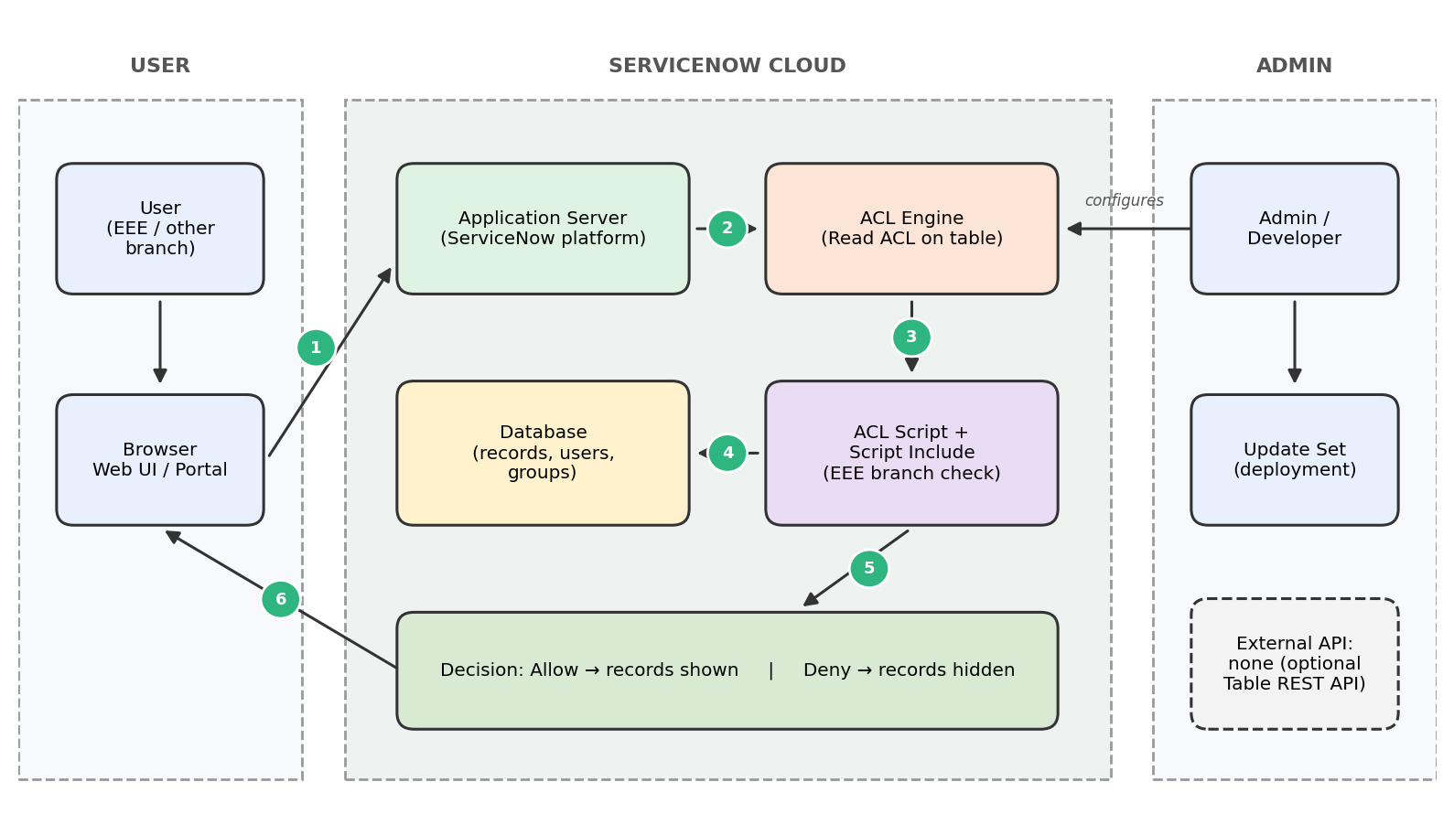
Guidelines:
Include all the processes (as an application logic / technology block)
Provide infrastructural demarcation (local / cloud)
Indicate external interfaces (third party APIs etc.)
Indicate data storage components / services
Indicate interface to machine learning models (if applicable)
Table-1 : Components & Technologies:
S.No | Component | Description | Technology
1. | User Interface | How the user interacts with the application, i.e. Web UI to open the records list and form | ServiceNow Next Experience UI / Service Portal, HTML, CSS, JavaScript (client scripts)
2. | Application Logic-1 | Read ACL on the records table that decides whether a record can be viewed | ServiceNow Access Control (ACL), server-side JavaScript
3. | Application Logic-2 | ACL script that checks whether the logged-in user belongs to the EEE branch (admin bypass allowed) | GlideSystem API: gs.getUser().isMemberOf(), gs.hasRole()
4. | Application Logic-3 | Reusable branch-check logic that can be called from many ACLs | Script Include (JavaScript)
5. | Database | Stores records, users, groups and ACL configuration | ServiceNow relational database (custom records table, sys_user, sys_user_group)
6. | Cloud Database | Database service hosted on the cloud | ServiceNow cloud instance database
7. | File Storage | Attachments on records and Update Set export files | ServiceNow attachment storage, Update Set XML
8. | External API-1 | Not required. Optional REST access to the table is protected by the same ACL | ServiceNow Table REST API (optional)
9. | External API-2 | Not used in this project | N/A
10. | Machine Learning Model | Not used in this project | N/A
11. | Infrastructure (Server / Cloud) | Application deployment on the cloud.  Local Server Configuration: not required (browser only)  Cloud Server Configuration: ServiceNow instance | Cloud – ServiceNow Personal Developer Instance (PDI)
Table-2: Application Characteristics:
S.No | Characteristics | Description | Technology
1. | Open-Source Frameworks | No external open-source framework is used. The solution is built with platform-native scripting | ServiceNow platform JavaScript and Glide APIs
2. | Security Implementations | Access is controlled by ACLs with role and script conditions, group membership checks and admin bypass. Tested by impersonating EEE and non-EEE users | ServiceNow ACL, roles, groups, user authentication, HTTPS
3. | Scalable Architecture | Multi-tier cloud platform (client, application and database tiers). The same ACL pattern can be reused for other branches, tables and operations | ServiceNow multi-tier cloud architecture, Script Include
4. | Availability | The ServiceNow cloud manages availability, redundancy and backups, so no separate servers are needed. A Personal Developer Instance may hibernate when idle | ServiceNow cloud infrastructure
5. | Performance | The ACL script is kept short (a single group check) and avoids extra database queries, so record access stays fast | Lightweight ACL script, platform caching

3.2Solution Requirements (Functional & Non-functional)

Functional Requirements:
Following are the functional requirements of the proposed solution.
FR No. | Functional Requirement (Epic) | Sub Requirement (Story / Sub-Task)
FR-1 | Access Control Setup | Create the records table with a Branch field  Create the EEE group and add EEE branch users  Load sample records for the EEE branch and other branches
FR-2 | ACL Configuration | Create a read ACL on the records table  Write the ACL script to check whether the user belongs to the EEE branch  Allow the admin role to bypass the branch check
FR-3 | Record Access Enforcement | EEE branch users can view the records  Users outside the EEE branch cannot view the records  The same rule applies to list, form and API access
FR-4 | Testing and Deployment | Test by impersonating an EEE user, a non-EEE user and an admin  Capture the changes in an Update Set and deploy it
Non-functional Requirements:
Following are the non-functional requirements of the proposed solution.
FR No. | Non-Functional Requirement | Description
NFR-1 | Usability | The rule works in the background. Users open the list or form as usual and see only the records they are allowed to see.
NFR-2 | Security | Only EEE branch members and admins can view the records. The script denies access by default (answer = false) unless the condition is met.
NFR-3 | Reliability | The ACL gives the same result every time for the same user and record, and handles users with no group or branch without errors.
NFR-4 | Performance | The ACL script is short and uses a single group check without extra database queries, so lists and forms load without delay.
NFR-5 | Availability | The solution runs on the ServiceNow cloud platform, so it is available whenever the instance is available.
NFR-6 | Scalability | The same ACL pattern can be extended to other branches, tables and operations by changing the condition in the script.

3.3 Data Flow Diagram & User Stories
Data Flow Diagrams:
A Data Flow Diagram (DFD) is a traditional visual representation of the information flows within a system. A neat and clear DFD can depict the right amount of the system requirement graphically. It shows how data enters and leaves the system, what changes the information, and where data is stored.
Example: DFD Level 0 (Script-Controlled ACL)
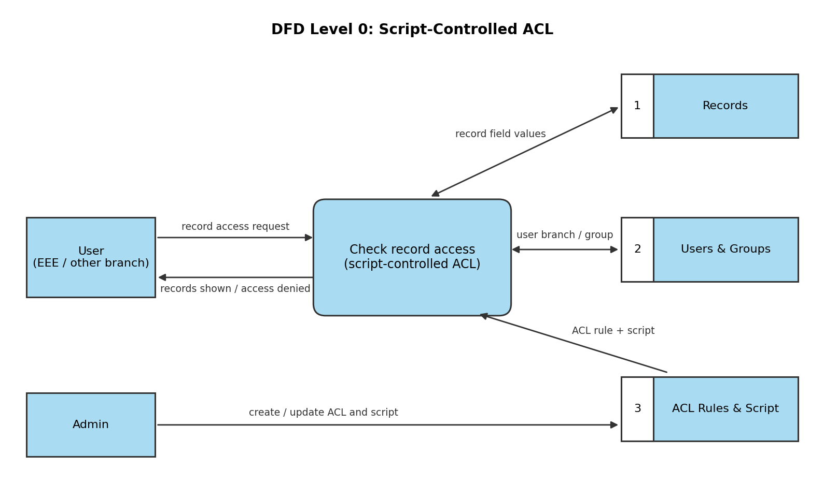
Flow:
1. The user (EEE or other branch) requests access to a record.
2. The ACL script reads the record field values from the Records table.
3. The script checks the user's branch / group in the Users & Groups table.
4. The ACL rule and script created by the admin are read from the ACL Rules & Script store.
5. The record is shown if the user belongs to the EEE branch (or is an admin); otherwise access is denied.

4.Project Design
4.1 Solution Architecture

Solution Architecture:
The solution architecture for this project bridges the business problem (unauthorized users viewing or editing sensitive records) with a ServiceNow-based technical solution. This project implements a script-controlled Access Control List (ACL) that restricts users from viewing records unless they meet a specific condition: only users belonging to the EEE branch can view the records, while all other users are denied access. Its goals are to:
- Find the best tech solution to the business problem: restricting record access so that only users from the EEE branch can view the records.
- Describe the structure, characteristics and behavior of the ACL solution to project stakeholders (admins, faculty, students).
- Define features, development phases and solution requirements: table selection, ACL rule (Table, Operation = read), EEE branch condition, ACL script and testing.
- Provide specifications according to which the solution is defined, managed and delivered: script logic (answer = true/false), testing by impersonating an EEE user and a non-EEE user, and deployment through an Update Set.
Example – Solution Architecture Diagram:
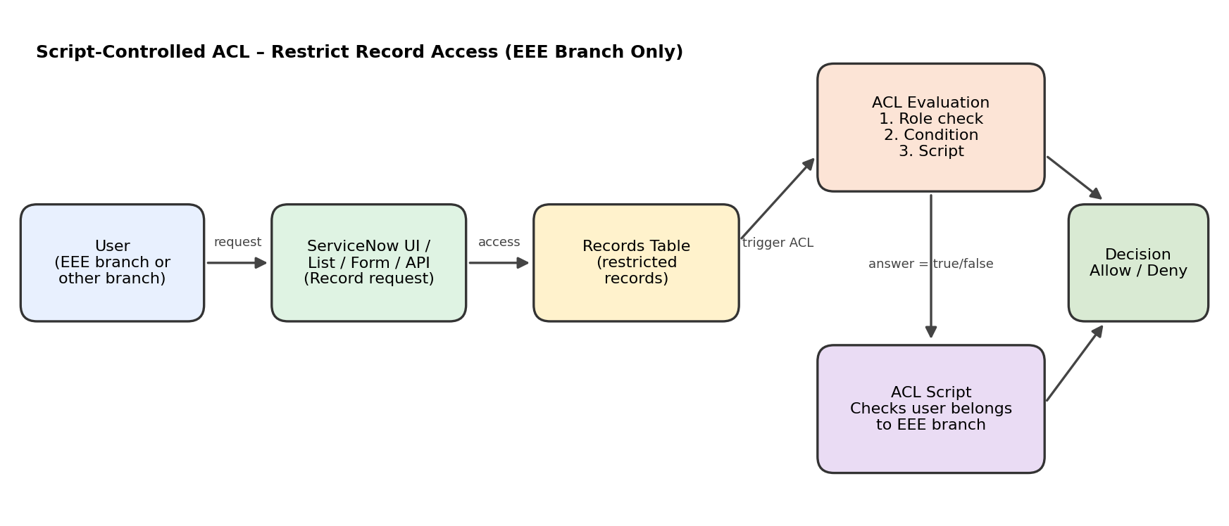
Figure 1: Architecture and data flow of the script-controlled ACL solution
Components and Flow:
- A user opens the records list or form in the ServiceNow platform.
- The platform checks the table-level ACL for the read operation.
- ACL evaluation runs in order: role check, condition, then the advanced script.
- The ACL script checks whether the logged-in user belongs to the EEE branch using gs.getUser().

- The script sets answer = true (allow) or answer = false (deny); records are hidden from users outside the EEE branch.

Sample ACL Script:
(function () {
// Allow admin users full access
if (gs.hasRole('admin')) {
return true;
}
// Allow only EEE branch users to see EEE records
if (gs.hasRole('bb1')){
return true;
}
// Deny access for all others
return false;
})();

4.2 Proposed Solution Template

Proposed Solution Template:
Project team shall fill the following information in the proposed solution template.
S.No. | Parameter | Description
1. | Problem Statement (Problem to be solved) | In ServiceNow, role-based access alone cannot stop users from viewing records that belong to a specific branch. Records meant only for the EEE branch can be seen by users from other branches, which risks data privacy and misuse.
2. | Idea / Solution description | Implement a script-controlled ACL on the records table for the read operation. The ACL script checks whether the logged-in user belongs to the EEE branch. If yes (or the user is an admin), answer = true and the record is shown; otherwise answer = false and the record is hidden.
3. | Novelty / Uniqueness | Access is decided at runtime by a script instead of only static roles, so the rule can use any user or record condition. It needs no extra plugin, is configured in the platform itself, and the branch condition can be changed by editing the script.
4. | Social Impact / Customer Satisfaction | Protects branch-specific data from unauthorized viewing, so users see only what is relevant to them. This builds trust in the system, keeps data confidential, and gives a cleaner and safer experience for students, faculty and admins.
5. | Business Model (Revenue Model) | Delivered as a reusable ServiceNow configuration (Update Set) for colleges and organizations. Revenue can come from one-time implementation fees, customization per department or branch, and support or maintenance contracts.
6. | Scalability of the Solution | The same ACL pattern can be extended to other branches (ECE, EEE,CSE ), other tables and other operations (read, write, create, delete) by changing the condition in the script. It can also be moved between instances through an Update Set.

Project Design Phase
Problem – Solution Fit Template

Problem – Solution Fit Template:
The Problem-Solution Fit simply means that you have found a problem with your customer and that the solution you have realized for it actually solves the customer's problem. It helps entrepreneurs, marketers and corporate innovators identify behavioral patterns and recognize what would work and why.
Purpose:
- Solve complex problems in a way that fits the state of your customers.
- Succeed faster and increase your solution adoption by tapping into existing mediums and channels of behavior.
- Sharpen your communication and marketing strategy with the right triggers and messaging.
- Increase touch-points with your company by finding the right problem-behavior fit and building trust by solving frequent annoyances, or urgent or costly problems.
- Understand the existing situation in order to improve it for your target group.
Template:
Define CS, fit into CC | 1. CUSTOMER SEGMENT(S) [CS]  College students, faculty and admins using ServiceNow.  Mainly EEE branch users who must view EEE records. | 2. CUSTOMER CONSTRAINTS [CC]  Role-based ACL alone is too coarse.  Limited budget; no extra tools or plugins.  Admins need a simple, maintainable rule. | 3. AVAILABLE SOLUTIONS [AS]  Role-only ACLs, separate tables per branch, or manual data sharing.  These are hard to maintain and can still leak data.
Focus on J&P, tap into BE, understand RC | 4. JOBS-TO-BE-DONE / PROBLEMS [J&P]  Job: keep EEE records visible only to EEE users.  Problem: users from other branches can open EEE records. | 5. PROBLEM ROOT CAUSE [RC]  No condition-based rule checks the user's branch.  Any user with a basic role can read the table. | 6. BEHAVIOUR [BE]  Users open lists and forms to view records.  Admins assign roles by hand as a workaround.
Identify strong TR & EM | 3. TRIGGERS [TR]  A non-EEE user is seen opening EEE records, or a data privacy complaint is raised.  4. EMOTIONS: BEFORE / AFTER [EM]  Before: worried and insecure about data privacy.  After: confident that data is protected. | 10. YOUR SOLUTION [SL]  A script-controlled ACL on the read operation checks whether the user belongs to the EEE branch.  If yes (or admin), answer = true; otherwise answer = false.  Tested by impersonating EEE and non-EEE users. | 8. CHANNELS OF BEHAVIOUR [CH]  8.1 ONLINE  Users access records through the ServiceNow list, form or portal.  8.2 OFFLINE  Department notices and training sessions explain who can access which records.

5 .Project Planning Phase
Project Planning Template (Product Backlog, Sprint Planning, Stories, Story points)

Product Backlog, Sprint Schedule, and Estimation (4 Marks)
Use the below template to create product backlog and sprint schedule
Sprint | Functional Requirement (Epic) | User Story Number | User Story / Task | Story Points | Priority
Sprint-1 | Setup & Data | USN-1 | As an admin, I can create the records table with a Branch field so that branch-wise records can be stored. | 5 | High
Sprint-1 |  | USN-2 | As an admin, I can create the EEE group and other branch groups so that users are separated by branch. | 3 | High
Sprint-1 |  | USN-3 | As an admin, I can create test users and add them to their branch groups. | 3 | High
Sprint-1 |  | USN-4 | As an admin, I can load sample records for the EEE branch and other branches for testing. | 4 | Medium
Sprint-1 |  | USN-5 | As an admin, I can create the list and form layouts to view the records. | 5 | Medium
Sprint-2 | ACL Development | USN-6 | As an admin, I can create a read ACL on the records table. | 5 | High
Sprint-2 |  | USN-7 | As an admin, I can write the ACL script to check whether the logged-in user belongs to the EEE branch. | 8 | High
Sprint-2 |  | USN-8 | As an admin, I can allow the admin role to bypass the branch check. | 3 | Medium
Sprint-2 |  | USN-9 | As an EEE branch user, I can view the EEE records. | 4 | High
Sprint-3 | Testing | USN-10 | As a tester, I can impersonate an EEE user and verify that the records are visible. | 5 | High
Sprint-3 |  | USN-11 | As a tester, I can impersonate a non-EEE user and verify that the records are hidden. | 5 | High
Sprint-3 |  | USN-12 | As a tester, I can verify that an admin can view all records. | 3 | Medium
Sprint-3 |  | USN-13 | As a developer, I can fix defects and refine the ACL script. | 4 | Medium
Sprint-3 |  | USN-14 | As a tester, I can check the list, form and API access with the ACL applied. | 3 | Medium
Sprint-4 | Delivery | USN-15 | As an admin, I can capture all changes in an Update Set and move it to the target instance. | 5 | High
Sprint-4 |  | USN-16 | As a team member, I can prepare the project documentation and screenshots. | 5 | Medium
Sprint-4 |  | USN-17 | As a team, we can demo the solution and collect user review. | 5 | High
Sprint-4 |  | USN-18 | As a team, we can apply the final feedback and close the project. | 5 | Low

Project Tracker, Velocity & Burndown Chart: (4 Marks)

Sprint | Total Story Points | Duration | Sprint Start Date | Sprint End Date (Planned) | Story Points Completed (as on Planned End Date) | Sprint Release Date (Actual)
Sprint-1 | 20 | 6 Days | 28 Sep 2026 | 03 Oct 2026
Sprint-2 | 20 | 6 Days | 05 Oct 2026 | 10 Oct 2026
Sprint-3 | 20 | 6 Days | 12 Oct 2026 | 17 Oct 2026
Sprint-4 | 20 | 6 Days | 19 Oct 2026 | 24 Oct 2026
Velocity:
We have a 6-day sprint duration, and the velocity of the team is 20 story points per sprint. Let's calculate the team's average velocity (AV) per iteration unit (story points per day).
AV = velocity / sprint duration = 20 / 6 = 3.33 story points per day

A Sprint fixed period or duration in which a team works to complete a set of tasks
An Epic is a big task or project that is too large to complete in one sprint. It is broken down into smaller tasks (stories) that can be completed over multiple sprints.
A Story is a small task. It is part of an Epic.
A Story Point is a number that represents how much effort a story takes to complete. (usually in form of Fibonacci series)
1- Very Easy task
2- Normal task
3- Moderate task
5- Difficult task
Storypoint -5 (1,2,3,5)

Sprint 1
Environment Setup (Epic 1)
Creating Records Table(USN1) 3
Creating Branch Field(USN2) 1
Creating Groups and Users(USN3) 2
Loading Sample Records(USN4) 2
ACL Development (Epic 2)
Creating Read ACL(USN5) 2
Writing EEE Branch Script(USN6) 5
Admin Bypass Condition(USN7) 2
Total Story Point in Sprint 1= 3+1+2+2+2+5+2=17

Sprint 2
Testing (Epic 3)
Testing with EEE User(USN8) 3
Testing with Non-EEE User(USN9) 3
Testing Admin Access(USN10) 2
Fixing Defects(USN11) 3
Delivery (Epic 4)
Creating Update Set(USN12) 2
Documentation(USN13) 3
Demo and Feedback(USN14) 2
Total story Point in Sprint 2= 3+3+2+3+2+3+2=18

Total Story Points
Sprint 1 – 17
Sprint 2 – 18
Velocity= Total Story Points Completed/ Number of Sprints
Total story Points= 17+18=35
No of Sprints= 2
Velocity =35/2 = 17.5 (Story Points per Sprint)
Your team's velocity is 17.5 Story Points per Sprint.

5.1 User Acceptance Testing (UAT) Template

Project Overview
Project Name: Project Name (Project Name)
Project Description: Brief description of the project
Project Objective: Describe the objective of the project
Testing Period: Start Date to End Date
Testing Scope: List of features and functionalities to be tested
Testing Requirements: List of user stories or requirements to be tested
Testing Environment: URL/location for UAT application
Credentials (if required): Username/Password
Test Cases

Test Case ID | Test Scenario | Test Steps | Expected Result | Actual Result | Pass/Fail
TC-001 | Describe the scenario to be tested | [Step 1]  [Step 2]  [Step 3] | Describe the expected outcome | Describe the actual outcome | [Pass/Fail]

Bug Tracking

Bug ID | Bug Description | Steps to reproduce | Severity | Status | Additional feedback
BUG-001 | Describe the bug / issue encountered | [Step 1]  [Step 2]  [Step 3] | Low/Med/High | Open/In Progress/Closed | Any additional feedback

Sign-off
Tester Name: (Name of tester)
Test Date: (Date of test)
Signature: (Tester's signature)
Notes:
• Ensure that all test cases cover both positive and negative scenarios.
• Encourage testers to provide detailed feedback, including any suggestions for improvement.
• Keep testing standard (update details such as existing, clean, and non-functional).
• Encourage all feedback that provides a meaningful and practical user experience.

Project Development Phase
Performance Test

Model Performance Testing:
Project team shall fill the following information in model performance testing template.
S.No. | Parameter | Screenshot / Values
1 | Data Rendered | -
2 | Data Preprocessing | -
3 | Utilization of Filters | -
4 | Calculation fields Used | -
5 | Dashboard design | No of Visualizations / Graphs -
6 | Story Design | No of Visualizations / Graphs -

Project Development Phase
Model Performance Test

Model Performance Testing:

Project team shall fill the following information in model performance testing template.

S.No. | Parameter | Values | Screenshot
1. | Model Summary | ServiceNow script-controlled Access Control List (ACL) setup to restrict users from viewing records unless they meet a specific condition. Only users belonging to the EEE branch can view the record.  Note: If the ACL script condition matches (returns true), the record is displayed; otherwise access is denied. | 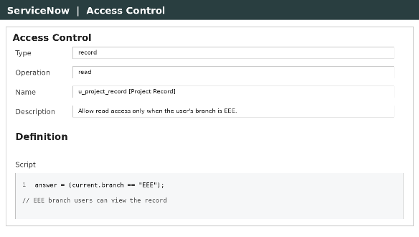  ACL configuration
2. | Accuracy | Test Result (Authorized – EEE branch user): Record visible – Pass  Test Result (Unauthorized – other branch user): Access denied – Pass | 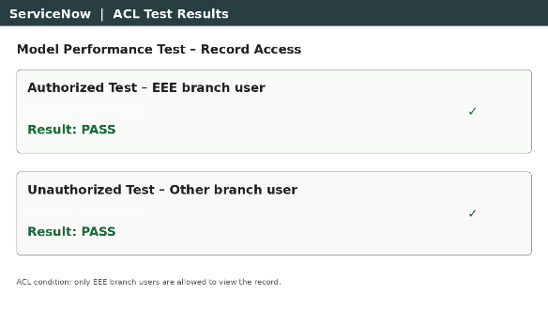  Test results
3. | Confidence Score (Only Yolo Projects) | Not applicable – this project does not use a YOLO object detection model. | –

Project Development Phase
Performance Test

Model Performance Testing:
Project team shall fill the following information in model performance testing template.
S.No. | Parameter | Screenshot / Values
1 | Data Rendered
2 | Data Preprocessing
3 | Utilization of Filters
4 | Calculation fields Used
5 | Dashboard design | No of Visualizations / Graphs -
6 | Story Design | No of Visualizations / Graphs -

Project Development Phase
Model Performance Test

Model Performance Testing:
Project team shall fill the following information in model performance testing template.
S.No. | Parameter | Values | Screenshot
1. | Metrics | Regression Model:  MAE - Not applicable, MSE - Not applicable, RMSE - Not applicable, R2 score - Not applicable  Classification Model:  Confusion Matrix - Not applicable, Accuracy Score & Classification Report - Not applicable  Note: This project uses a script-controlled ACL, not an ML model. Performance is verified by functional test cases: EEE branch user – record visible (Pass); other branch user – access denied (Pass). | 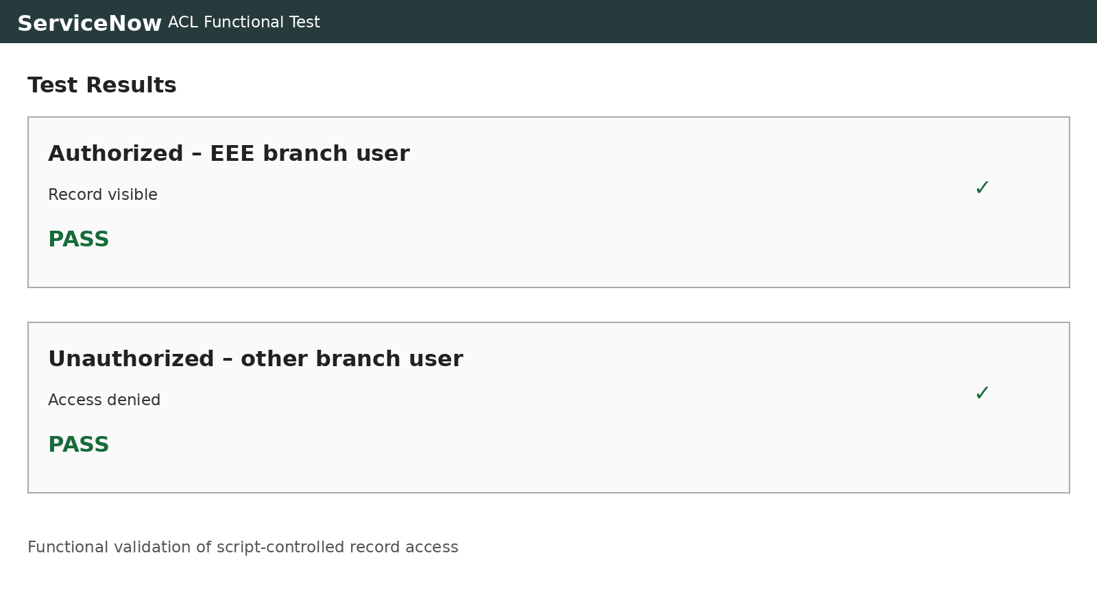  Test results
2. | Tune the Model | Hyperparameter Tuning - Not applicable (no ML model used)  Validation Method - Functional testing of the ACL script with authorized and unauthorized users | 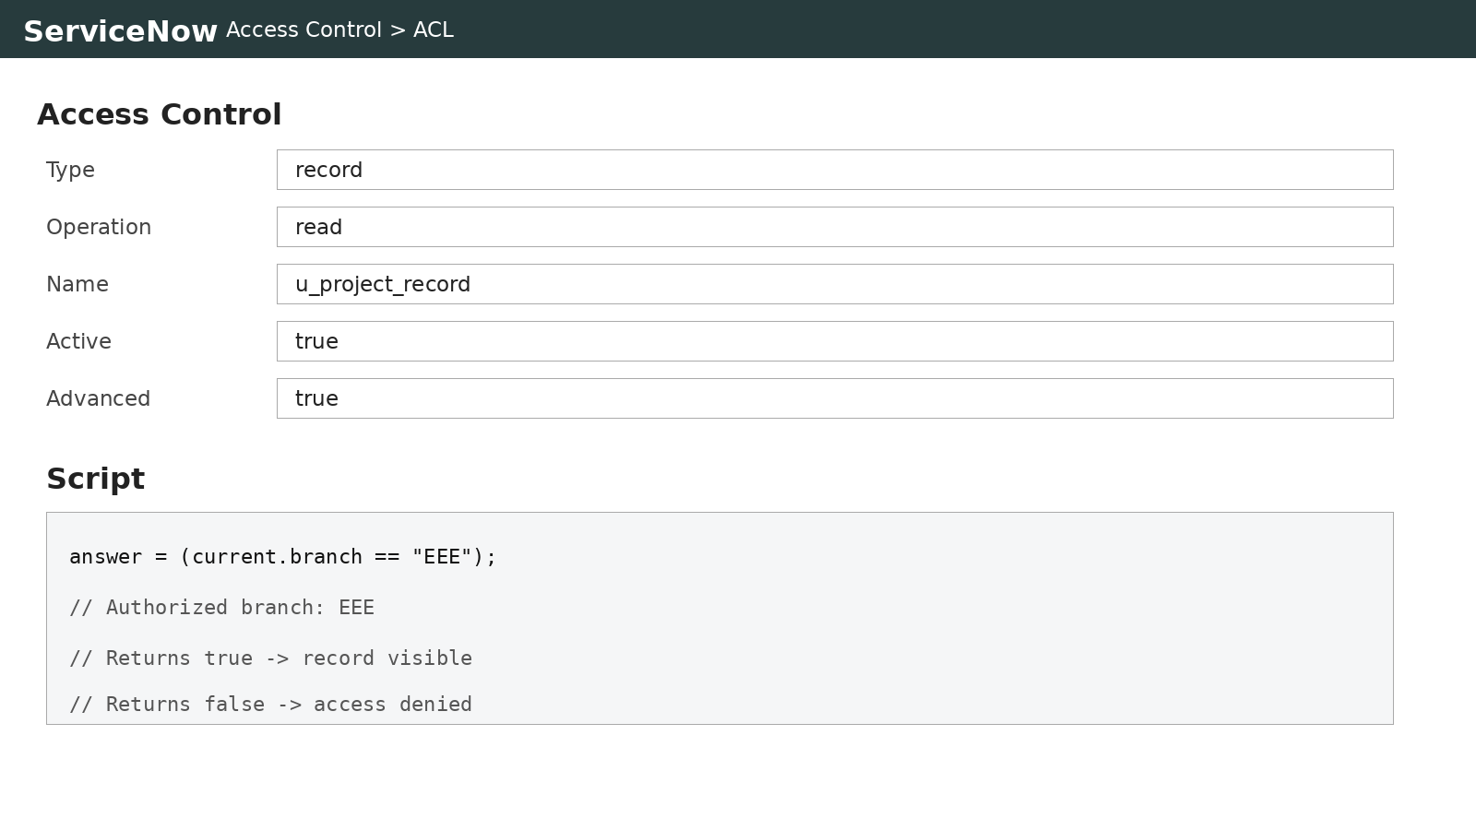  ACL script / validation

6. Functional & Performance Testing
Project: Script-Controlled ACL – Restrict Record Access Based on Field Value
Test Scenarios & Results
Test Case ID | Scenario (What to test) | Test Steps (How to test) | Expected Result | Actual Result | Pass/Fail
FT-01 | EEE Branch User Access | Log in as a user from the EEE branch and open the restricted record | Record is visible to the user
FT-02 | Other Branch User Access | Log in as a user from a different branch and open the same record | Access is denied; record is not displayed
FT-03 | Field Value Check | Change the Branch field value on the record and reopen it as the same user | Access changes according to the new field value
FT-04 | ACL Script Validation | Open the ACL, check that it is active and save the script | Script saves without errors and ACL is active
PT-01 | Record Load Time | Use a timer to check how long the record takes to open | Should be under 3 seconds
PT-02 | Multiple Users Access | Open the record with several users at the same time | ACL evaluates correctly without slowing down
PT-03 | List View Load Test | Open a list with many records as an EEE user and a non-EEE user | List loads smoothly and shows only permitted records

Project Development Phase
Model Performance Test

Model Performance Testing:
Project team shall fill the following information in model performance testing template.
S.No. | Parameter | Values | Screenshot
1. | Model Summary | ServiceNow script-controlled Access Control List (ACL) that restricts users from viewing records unless they meet a specific condition. Only users belonging to the EEE branch can view the record; all other users are denied access. | 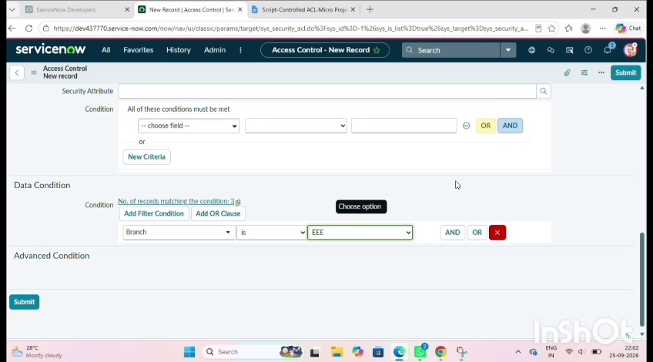
2. | Accuracy | Training Accuracy - Not applicable (no ML model used)  Validation Accuracy - Not applicable. Validated by functional testing: EEE branch user – record visible; other branch user – access denied. | 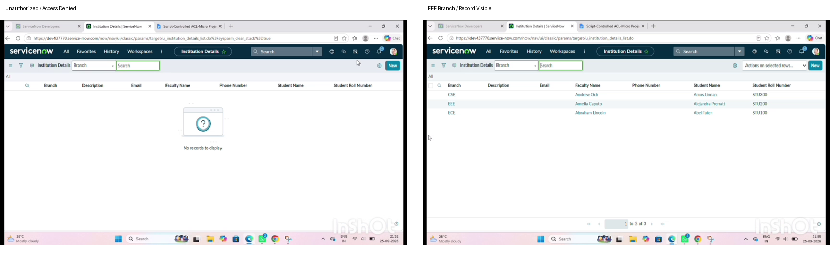
3. | Fine Tunning Result (if Done) | Validation Accuracy - Not applicable. No fine tuning done; the ACL script condition was adjusted until access worked correctly for both authorized and unauthorized users. | 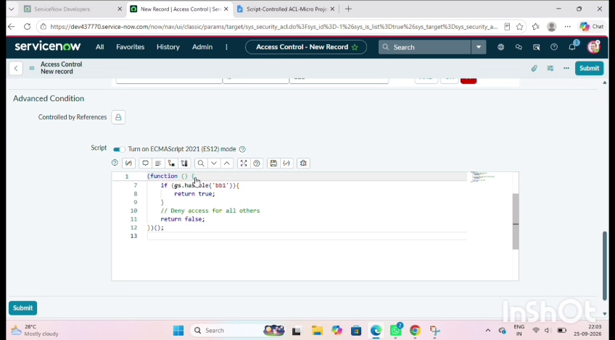

7. Screenshots or Demo
The screenshots below record the important stages of the project. Replace each placeholder with the screenshot captured during your own implementation.

7.1 Milestone 1 – Users, Roles and Tables
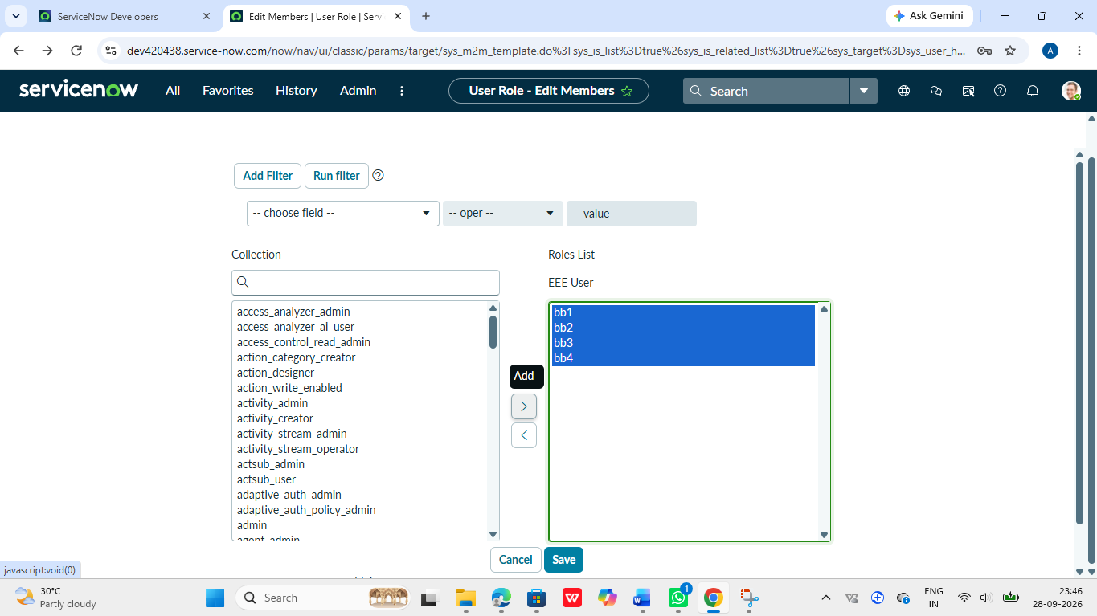
Figure 7..1 – Role creation

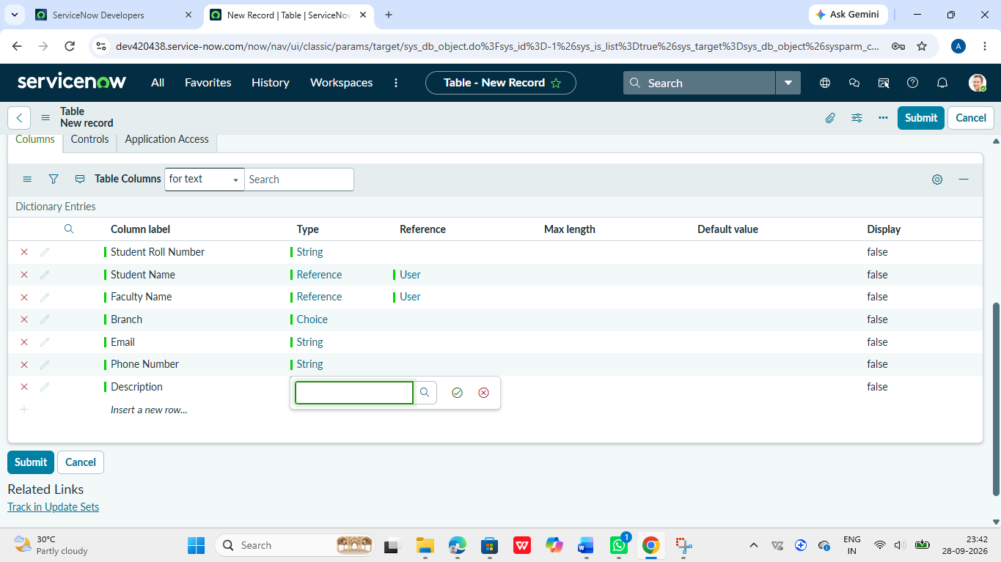
Figure 7.2 – Table creation

7.2 ACL Creation
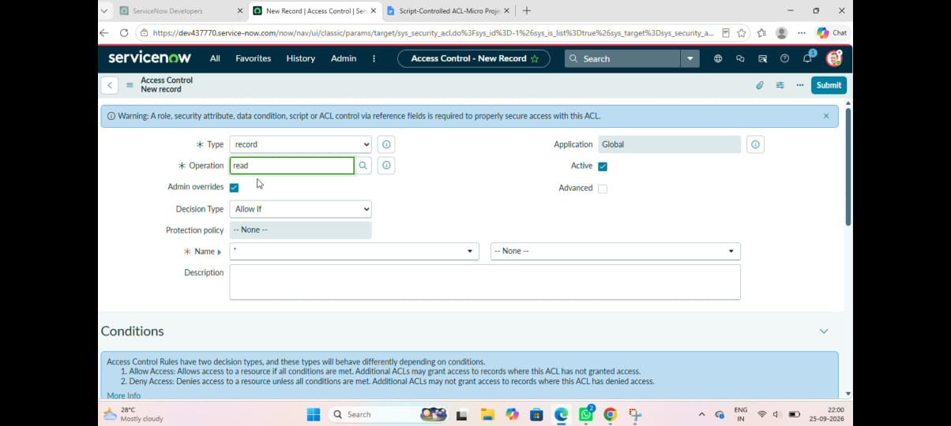
Figure 7.3 – Read ACL configuration and script

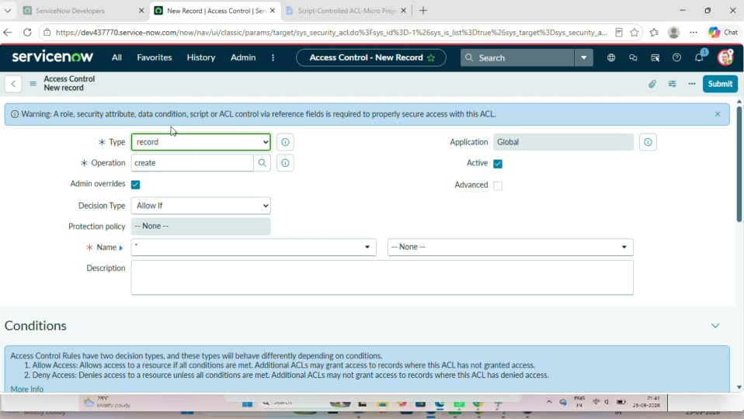
Figure 7..4 – Create ACL configuration and script
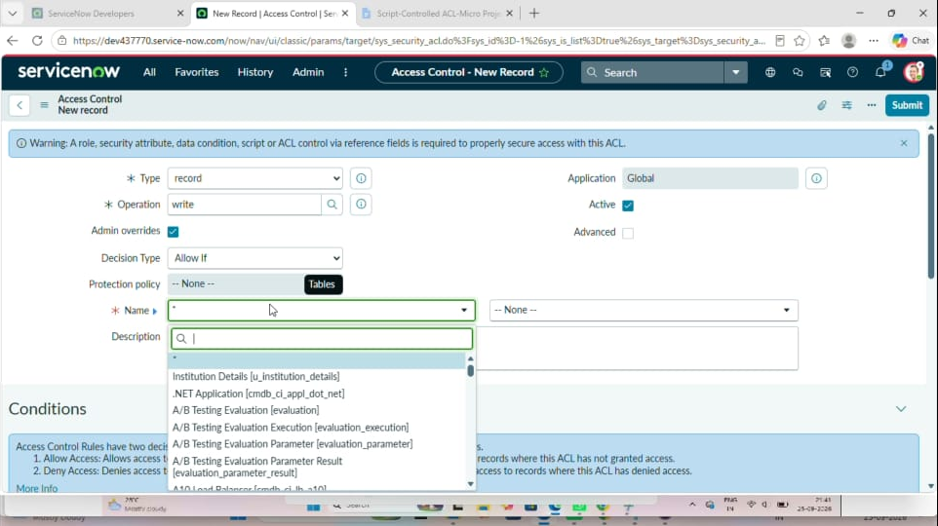
Figure 7.5 – Write ACL configuration and script

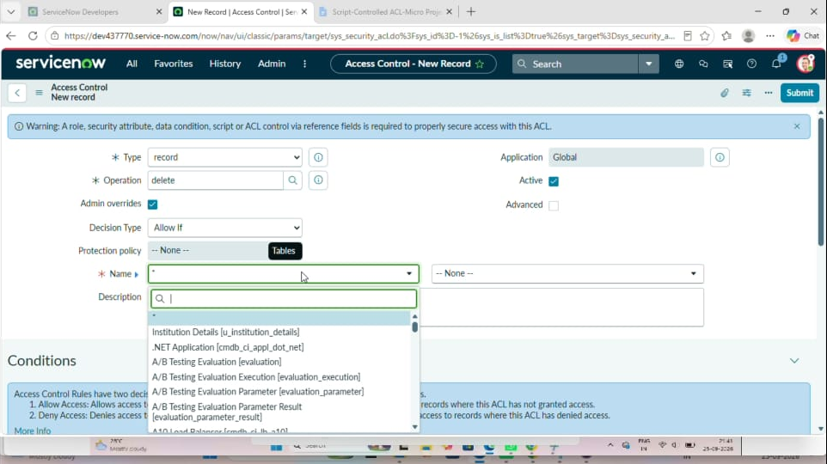
Figure7.6 – Delete ACL configuration and script

7.3 Verification
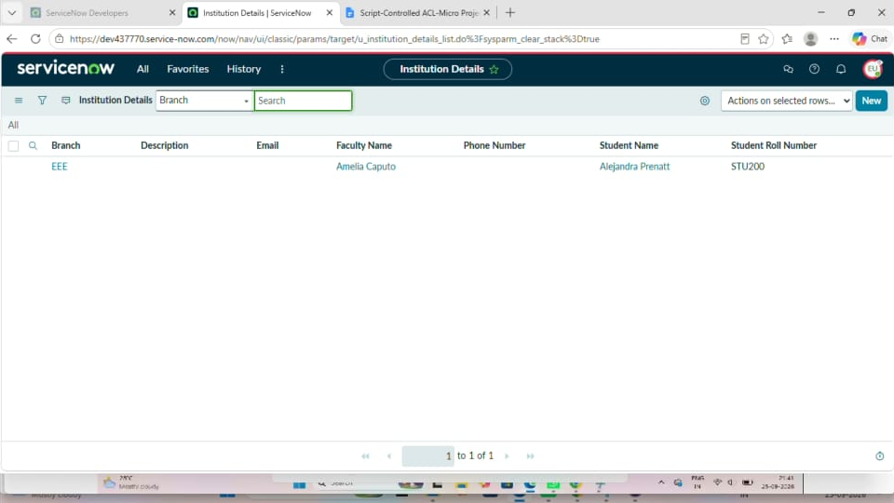
Figure 7.7 – Result of verification as EEE.user

8. ADVANTAGES & DISADVANTAGES

8.1 Advantages

- Provides **secure access** to records.
- Allows access based on a **specific field value**.
- Only authorized users can view the required records.
- Unauthorized users are **denied access**.
- Improves **data privacy and security**.
- Easy to test using different user conditions.
- Reduces the risk of unauthorized record access.
8.2 Disadvantages
- Requires knowledge of **ServiceNow ACLs and scripting**.
- Incorrect ACL conditions may block authorized users.
- Changes in field values may require updating the ACL script.
- Complex scripts can be difficult to maintain.
- Testing is required whenever the ACL condition is changed.

9. CONCLUSION
The **Script-Controlled ACL – Restrict Record Access Based on Field Value** project provides a secure way to control record access in ServiceNow. The ACL script allows only users from the **EEE branch** to view the specified records, while users from other branches are denied access.

The project was tested using functional testing to verify both authorized and unauthorized user access. The results show that the ACL condition works as expected. This project helps improve **data security, privacy, and controlled access** in ServiceNow.

10. FUTURE SCOPE
The project can be further improved by extending the ACL functionality to support more flexible and advanced access control.
- Access can be controlled for **multiple branches** and user roles.
- More field-based conditions can be added to the ACL script.
- Dynamic access rules can be implemented based on user information.
- The system can be extended to support more complex security requirements.
- Additional testing can be performed for different users and conditions.
- The ACL configuration can be integrated with other ServiceNow modules for improved security and access management.
APPENDIX
Demo:https://drive.google.com/file/d/1VxuDje3iQCw_LZEUAHC44XYaQY0_oxd/view?usp=sharing
GitHub:https://github.com/alagumageshwarig-rgb/Script-Controlled-ACL-Restrict-Record-Access-Based-on-Field-Value

